American Orchid Society Northeast Judging Center
Orchid Auction
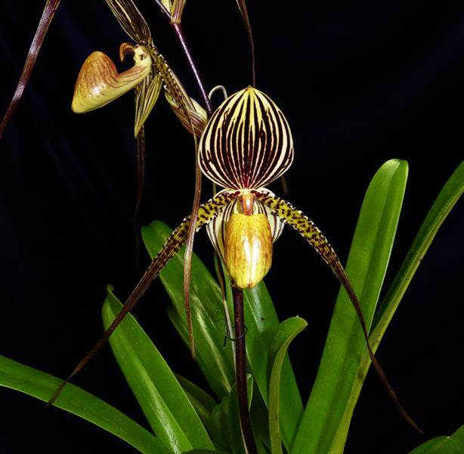
When: June 6, 2015
Where: Tower Hill
Botanical Garden
Boylston, MA
10:30AM auction starts
Auction preview at 10AM
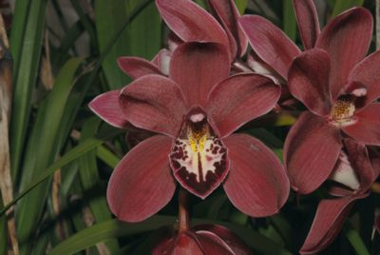
This will be some a great opportunity
to some collect some unique orchids finds,
some antique orchid prints.
There may also cheesecakes made Joseph
Maciaszek for lunch as well as for auction.

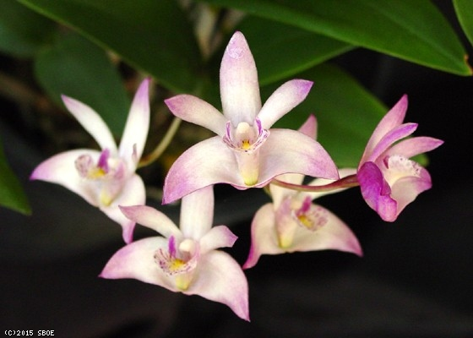
Tower Hill Botanical Gardens is located at
11 French Drive Boylston, MA.
Which be easily reach from either
interstates 290 or 495.

